The Micronesia Challenge: Sustainable coral reefs and fisheries

While island societies can do little to control carbon emissions from developed nations, they can manage their local resources to enhance the ecosystem services that coastal habitats, including reefs, provide for people. In this spirit, the political leaders of five nations in Micronesia initiated the Micronesia Challenge (MC) in 2006 as a commitment to ‘effectively conserve’ at least 30% of their marine resources and 20% of their terrestrial resources by 2020. With regards to coral reefs, the MC was established due to growing concerns of stressors such as climate change, unsustainable harvest of fisheries, and land-based pollution.

The tough thing about studying fishes, coral reefs and other marine ecosystems is that they are constantly moving and changing in response to natural variation, episodic disturbances, and human stressors. So how can scientists help managers measure the effectiveness of marine conservation efforts? This is the question new research in Micronesia is helping to answer led by the University of Guam Marine Laboratory (UOGML).

The new paper published in the academic journal PLOS ONE describes a way to measure coral-reef ecosystem condition, and predict the relative influence of key threats to coral reefs. “Perhaps the greatest challenge for the team of scientists from Yap to the Marshall Islands was establishing a ‘scorecard’ indicative of the fish, corals, and benthic substrates that all depend upon each other,” described Dr. Peter Houk (UOGML), the lead author of the study. “This was accomplished by using individual condition metrics, similar to our blood pressure and cholesterol, which combine to determine our health.” Armed with this approach, the researchers evaluated the current health of 78 reefs across 8 islands in Micronesia.

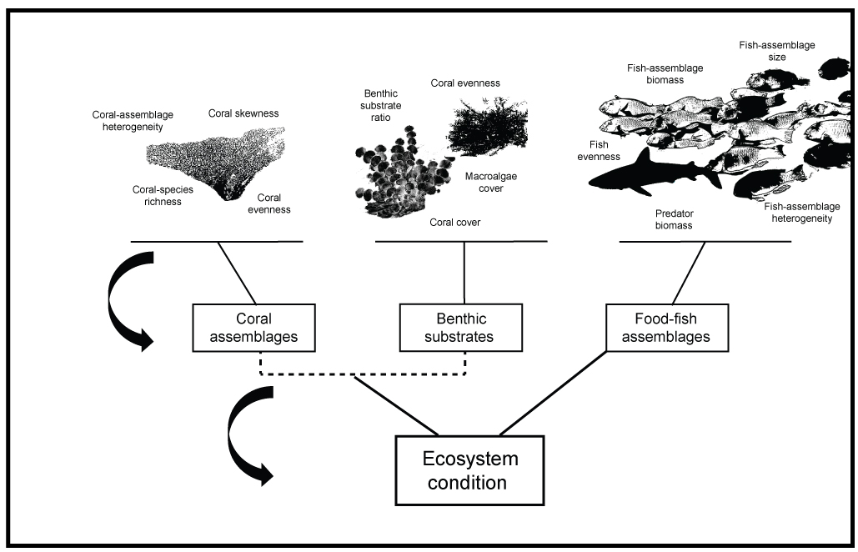
Figure shows the process by which individual measures of coral and fish communities were combined to assess overall ecosystem condition.

The results were a bit daunting, revealing that only 42 percent of the major reef habitats across Micronesia exceeded the thresholds established for the Micronesia Challenge. “Understanding current health was a key component of this research, but we also needed to evaluate why reefs in some localities were not as healthy as others. More specifically, we needed to understand if coral-reef status was due to natural environments or human stressors because we can only manage human stressors,” described Trina Leberer from The Nature Conservancy and co-author of the study.

For several islands with low human populations, such as Rota in the Mariana Islands and Namdrik Atoll in the Marshall Islands, wave energy alone was the best predictor of coral-reef condition, and so reefs were considered to be more-or-less in a natural state, and healthy. However, for the majority of islands with larger human populations, fishing pressure acting alone on the outer reefs, or in combination with pollution in some lagoons, was the best predictor of more than 50 percent of the reefs examined. “These results highlighted the ecological roles that healthy fisheries contribute to overall ecosystem function. When examined deeper, we found that the absence of predators and large herbivores on reefs was the strongest factor leading to the dominance of algae cover. Both have key functional roles that are threatened,” described Houk. Also interesting was the finding that the majority of marine protected areas across Micronesia are not currently living up to their full potential. This could be due to poor placement and natural factors, but was more likely a consequence of insufficient enforcement given that the fewer successful MPA’s were associated with dedicated community-based enforcement.

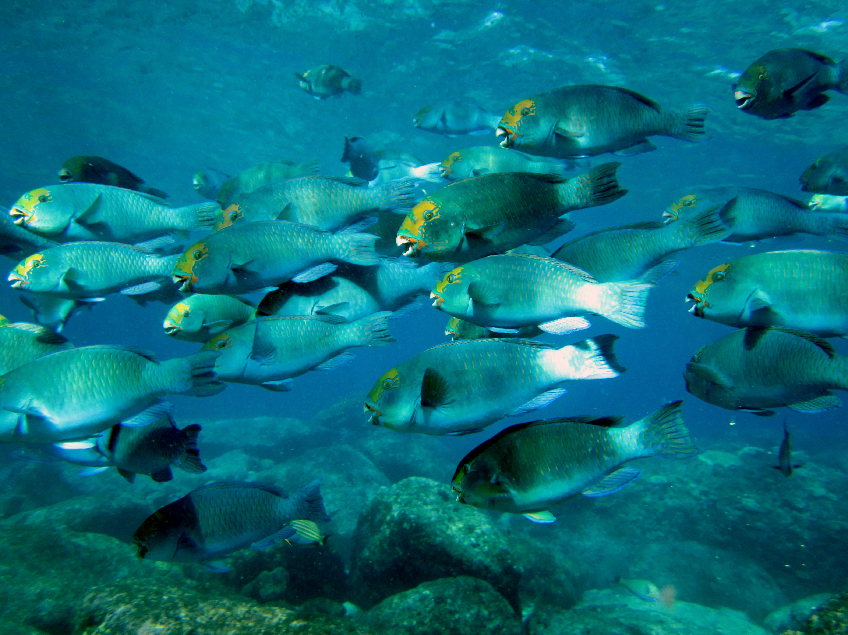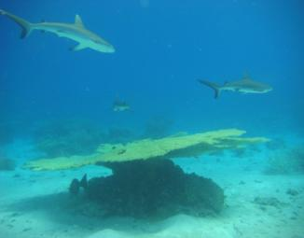
Striking a balance between harvesting large herbivores and predators and allowing for their functional roles in the ecosystem is a major challenge facing reefs in Micronesia.

“We have to start thinking outside the box and managing fisheries from many approaches, not just no-take marine protected areas,” suggested Eugene Joseph, executive director of the Conservation Society of Pohnpei and co-author. “Networks of scientists, community members, and the fishing community have begun coming together in Pohnpei and have together decided on new legislation that limits the harvesting and sizes of key predators and large herbivores. This legislation recently passed and is now a law. Enforcement and compliance is now the remaining issue we’re dealing with, and outreach to communities is a big part of that. Such practices of limiting our catches of certain species and size classes were common practices of traditional cultures.”

The results of the current study have pinpointed reefs that are not doing well, evaluated which stressors are most likely responsible, and finished by determining what aspects of the fish communities are most threatened. This represents a key step towards promoting healthy reefs and ecosystem services such as fisheries that they provide. Next steps include completing the assessment in Palau in coordination with the Palau International Coral Reef Research Center, and exploring interest in the possibility of conducting this type of assessment for Guam.

“Fishing is and will always be a cornerstone for societies and livelihoods in Micronesia. This requires that we have dedicated science-to-management frameworks in place to efficiently evaluate management, and help adapt policies when necessary,” concluded Houk. Specific details about progress in each jurisdiction can be found in the freely-available online report.

The authors thank the Micronesia Conservation Trust, the National Oceanic and Atmospheric Administration’s Coral Reef Conservation Program, and the David and Lucille Packard Foundation for supporting the collective efforts.

http://journals.plos.org/plosone/article?id=10.1371/journal.pone.0130823

