(Extract from 2nd Draft)

Chapter 4

Selected Examples of Current Interventions in the Pacific

This section will provide a brief update of baseline information on current coastal protection interventions around the Pacific region. It will highlight the various engineering approaches used by different countries in the region. It will describe why these approaches are effective? How successful are these structures and what the main features of the approaches are.

Cook Islands
In the Cook islands, the engineering approach used are concrete sea walls, rock boulder revetments, groynes, rock breakwater, and beach replenishment. Specific locations of interests are beach replenishment at northern coastline and rock mounted breakwater at Avatiu.

Federated State of Micronesia (FSM)
Seawalls, causeways and groynes are common engineering structures found in FSM.

Fiji
In Fiji they use causeways, bridges and seawalls. Fiji has an Integrated Coastal Zone management Plan in place. Protected coastal areas are the Great Astrolabe Reef in Ono island, Kadavu; Nadi Bay (Tai, Levuka, Vomo Sewa islands fringing and offshore reef areas); Namenalala fringing and barrier reefs; Yadua Taba fringing reefs and surrounding waters; and Lau group. The protected mangrove areas are Ba Delta-Nawaqarua-Natutu; Rewa Delta-Muanicake-Nasoata river; Labasa Delta-Labasa river and Labasa delta mouth.

Guam
The common coastal engineering approaches found in Guam are revetments, seawall at East Agana, Vegetation at Cocos Island, coral boulder revetment, concrete and rock seawall.

Kiribati
The types of interventions found in Kiribati are vertical coral rock seawalls, cement vertical coral rock wall, Gabion basket filled with coral, Sandbag filled with Sand, cement front wall, sloping coral rock wall with cement motor and causeways.

Nauru
The coastal engineering approaches used in Nauru are Coral boulder revetment and concrete and rock seawalls.

Niue
Niue is surrounded by natural high cliff structures which protects the island from waves and strong winds. A seawall was constructed at Avatele Bay. There are two MPA's one in Alofi and one in Makefu. (from Niue ICC Ms Birtha )

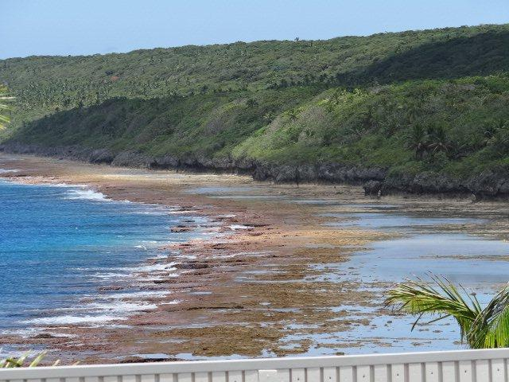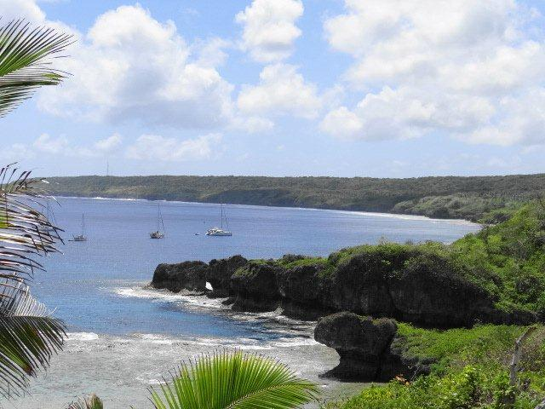
Figure 1 High Cliff of Tamakautoga, Niue Figure 2 High cliffs of Niue
Photo credit: Susanna Sionetuato Photo credit: Susanna Sionetuato

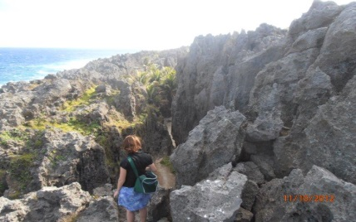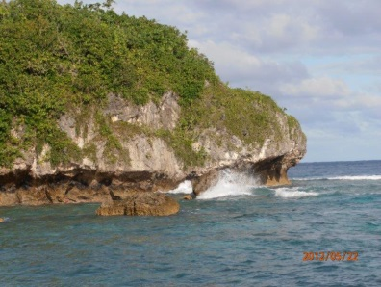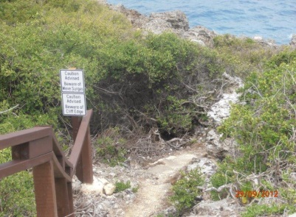
Figure 3 Walking down the cliff, Niue. Figure 4 Waves cuts the cliff below. Figure 5 Pathway down the cliff. Photo credit: Birtha Togahai.
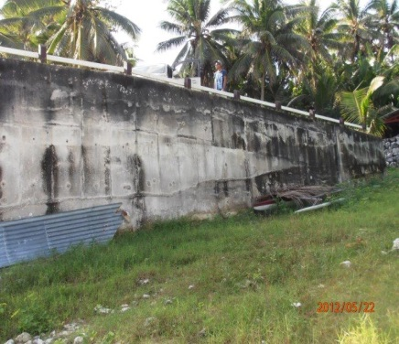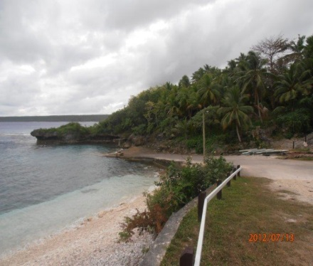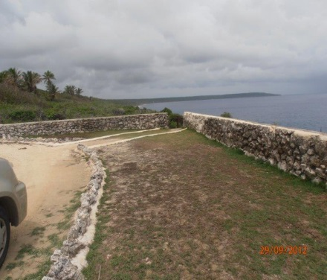
Figure 6 Tall Concrete wall Figure 7 Concrete Beach ramp, and seawall Figure 8 Stone wall at Matavai Resort. Photo credit: Birtha Toghai

Northern Mariana Islands
The coastal engineering structures found are seawalls, bulkheads, and beach nourishment at Beach Road.

Samoa
In Samoa the coastal engineering approaches are stone walls, volcanic boulders at Lufilufi, Vaiala beach seawall, semi vertical seawall at Tusitala Hotel, revetment at Aggie Grey’s Hotel, groynes at Mulinwu Pennisula, large rock at old Hideaway Hotel at Mulivai, Revetment and beach replenishment, Japanese funded seawall at Apia water front and at Utulei beach.
An update from (Ms Moira Faletutulu of the Ministry of Natural Resources and Environment, Samoa), the main approaches used in Samoa are hard structural armour rock revetments or seawalls and soft measures such as planting of mangroves and other salt tolerant coastal plant species. The designs and constructions of these interventions are done in an ad hoc basis. One standard design uses compacted backfill scoria material, geo textile cloth, secondary and primary armour rocks placed at right slope and height.

Republic of the Marshall Islands
Generally speaking, coastal protection in the RMI is intended to “hold the line” and maintain a fixed shoreline, i.e. limit erosion and to a lesser extent limit flooding and inundation. This is particularly evident in the populated centres of Majuro and Ebeye where
coastal protectionis largely ad hoc and undertaken at the level of individual landowners. Other than the revetment and seawall at the Majuro aiport, there have been few coordinated or centralized coastal engineering interventionspost-independence. Typically landowners will armour shorelines using any available material. Those with access to technical and financial resources will use rip-rap revetment and vertical concrete block or cemented coral walls. Gabion baskets filled with coral gravel are also used. More frequently, a mix of inorganic debris including tyres, scrap metal and old heavy machinery is used. Recently the RMI endorsed guidance in the form of a publication on options for coastal protection for landowners. University of Hawaii Sea Grant in association with RMI agencies is working with communities to broaden the application of options to include softer ridge-building and re-vegetation techniques, along with a more concentrated approach to reef and reef flat protection. While ongoing work in the outer atolls is still focusing on harder fortification measures and road elevation along causeways, the approach is becoming more integrated and innovative in terms of combining options where possible. This will have long term benefits of mainstreaming with other resource management objectives (e.g. reef protection) and making it more likely that benefits from limited adaptation funds can be used over a larger area.
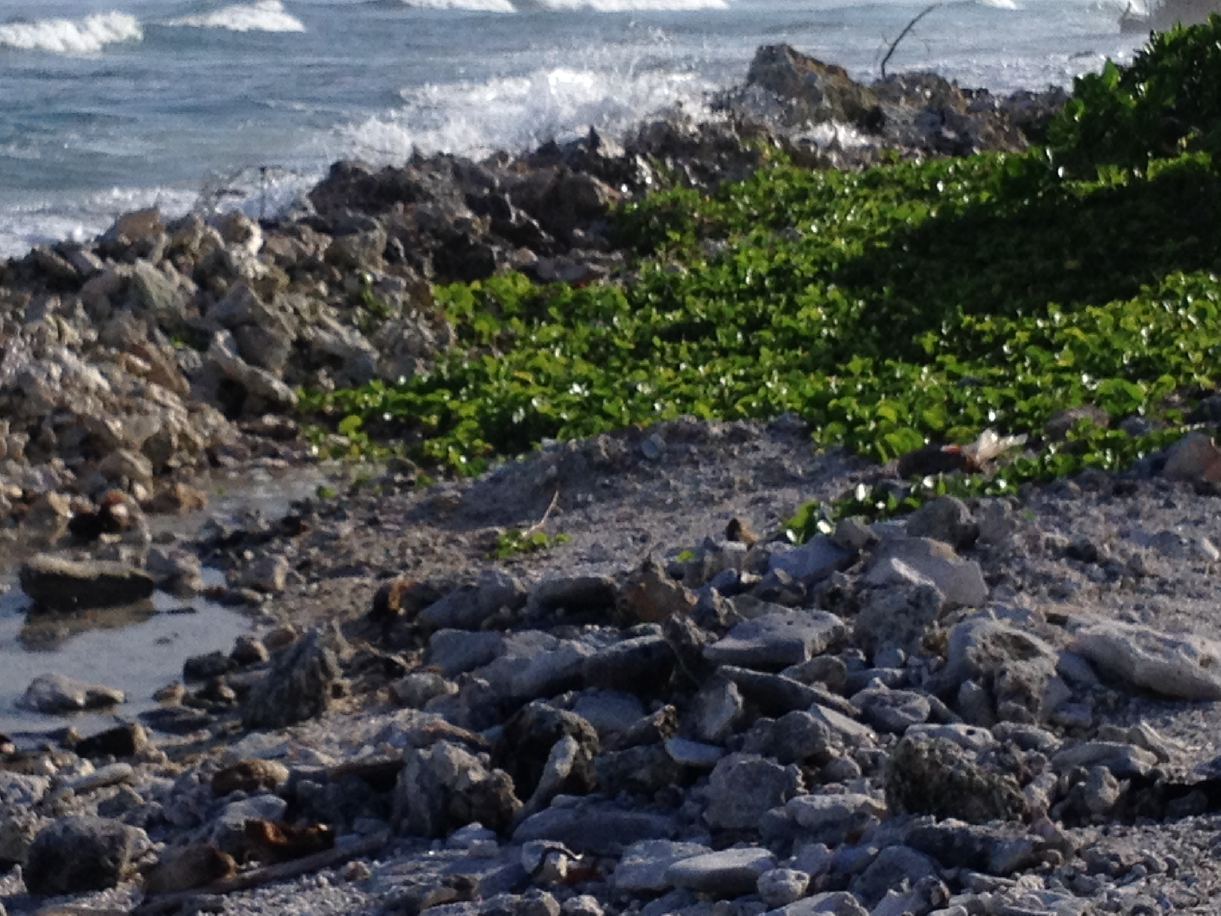
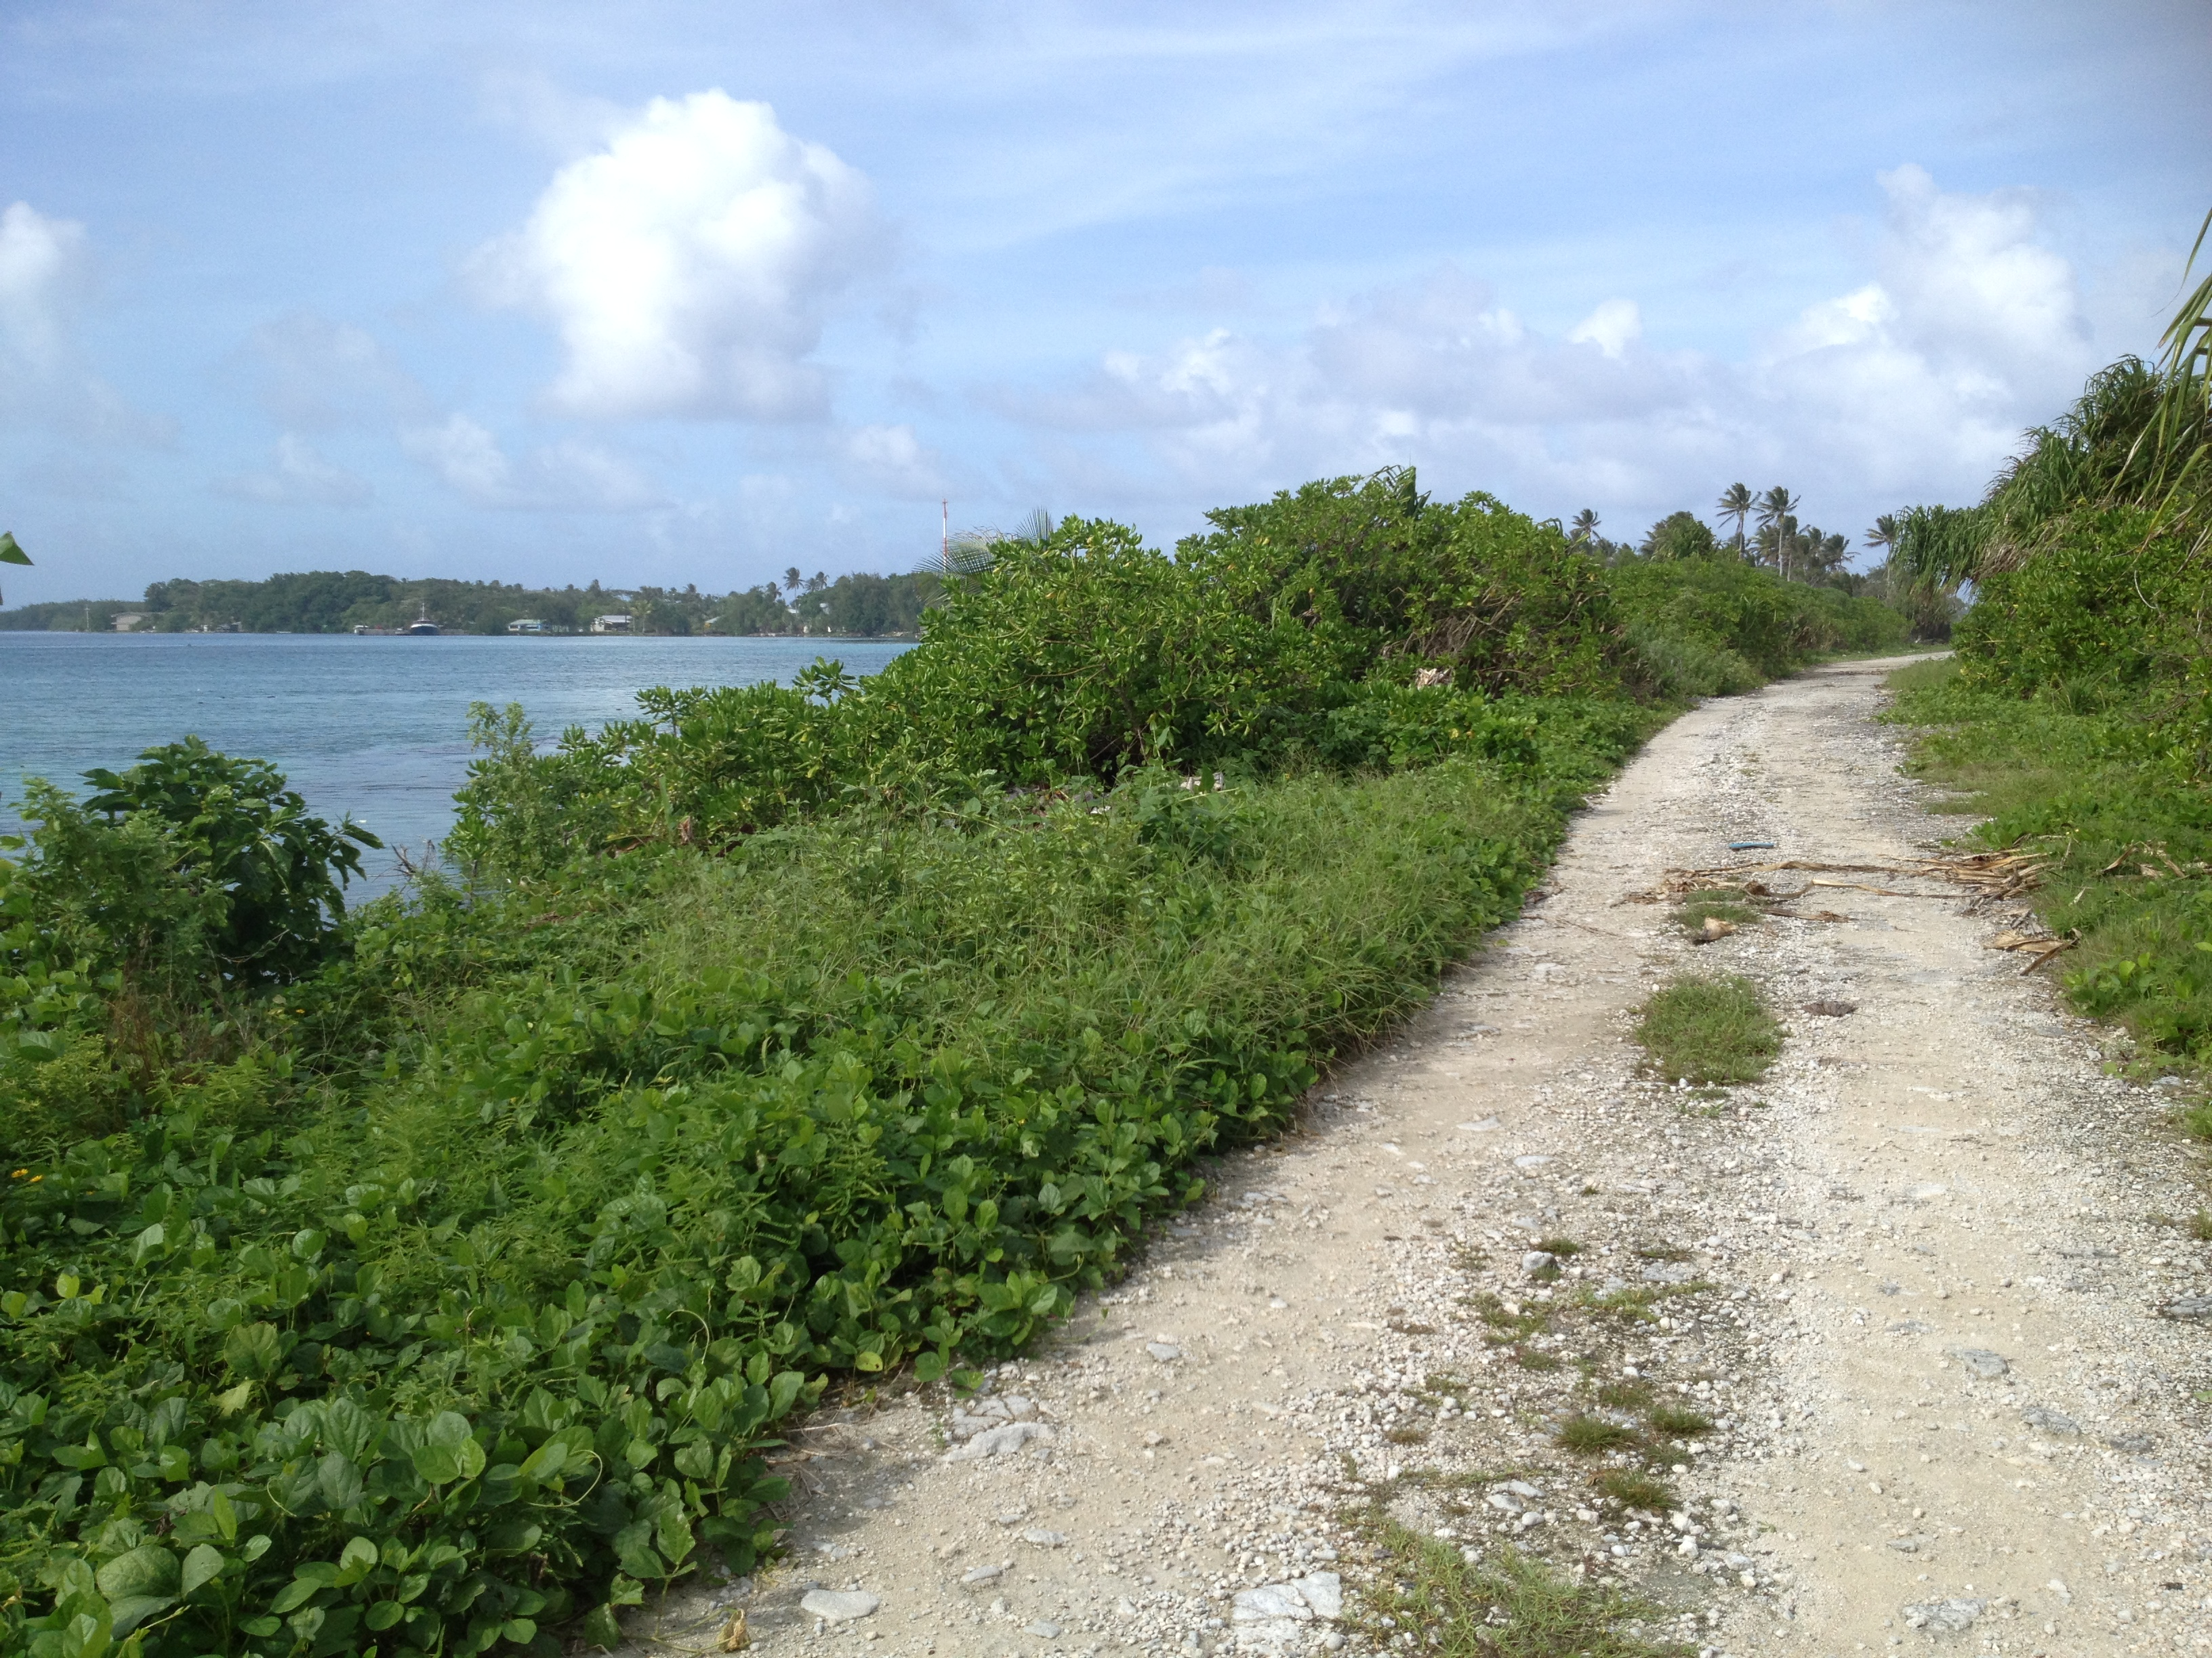

Palau

Papua New Guinea
In Papua New Guinea, coastal engineering approaches used are bricks and rock seawalls, dry stone seawalls, coral seawalls and boulders.
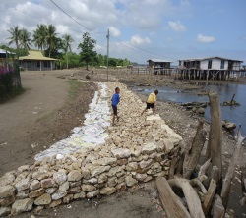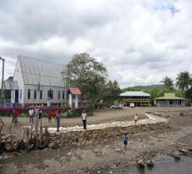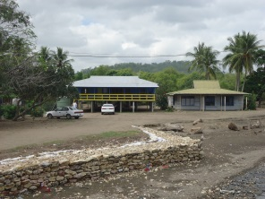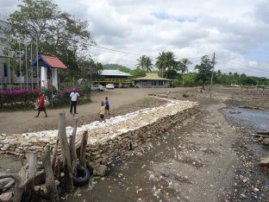
Figure 9 Dry stone seawalls at Gapagapa village, central province, PNG
Photo credit: Rose Godana.

Tonga
In Tonga, they use limestone boulder seawall at Nukualofa beachfront, and beach sand seawall at Hihifo in the western area. Breakwater in Eua Island. (An update from In Country Coordinator-Mr Tevita Fakaosi). The seawall at the waterfront of Nukualofa was constructed after cyclone Isaac of 1982 and completed around 1985-86. This was considered highly successful in protecting the beachfront in the capital area. The Kanokupolu Seawall was constructed by the villagers themselves with some assistance from NGOs, Governments and Donors. This has been very successful at preventing further erosion at the site, but once again a major head ache at the edge of the seawall where the neighboring villages are now facing coastal inundation at a greater magnitude and frequency. Soft engineering approaches have been conducted in more sheltered lagoon site villages such as Lapaha on the main island of Tongatapu. Mangrove replanting and coastal plant reforestation is ongoing as they attempt to reduce the impacts of inundation and coastal erosion. the use of sand bags was piloted by one community in Ha'apai. This project was not so successful as they used bags that were not durable, however the concept has its merits in terms of the availability of resources locally, just need some modification to get it right.

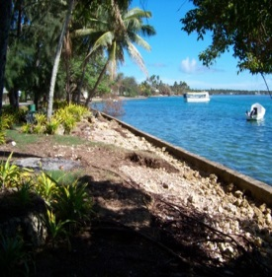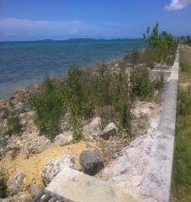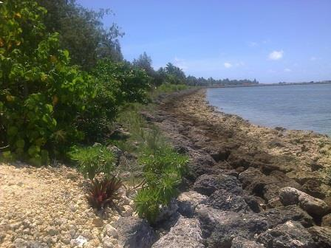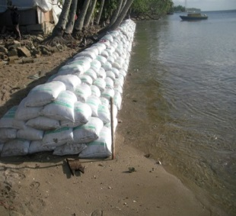
Figure 10 Concrete seawall. Figure 11 Waterfront seawall. Figure 12 Rock seawall. Figure 13 Sandbag seawall-Tonga (Photo credit: Tevita Fakaosi)

Tuvalu
In Tuvalu, the common engineering approaches are seawalls, gabion basket of stones, and concrete cube revetment.

Solomon Islands
(An update from Research Assistant John Whaleneanea). The most popular low cost engineering approach in the Solomon Islands for coastal protection is the use of seawalls. These are built from rock boulders from the surrounding coastal environment. In case of Figure 15, where the seawall is vulnerable to relatively intense wave action, the seawalls are reinforced by wooden pillar stuck into the benthos. Its life span is not that long therefore it requires community or family effort to maintain them.
Figure 16: Typical seawall made of coral boulders from the reefs reinforced by logs. The figure below is shot of the Southern end of Nola Hamlet in Ngawa Islet (Reef Islands grouping of Temotu Province). Seawalls like this are also reinforced by the roots of Abalolo trees that interlock the rocks together.
Mangrove forests also plays a major role in coastal protection in the Solomon Islands, unfortunately their exploitation have seen dramatic increase in densely populated areas around the country. The Langalanga Lagoon in Malaita the Solomon Islands has seen a great deal of mangrove deforestation in the last 15 years increasing coastal erosion. In Ngawa Island in the Reef Islands, the community in an attempt to protect their coasts from erosion, decided to plant mangrove trees, along their coast in the intertidal zone. The mangroves according to the villages have started aiding the retrieval of the coast line (see figure, 17). Initiatives like these can

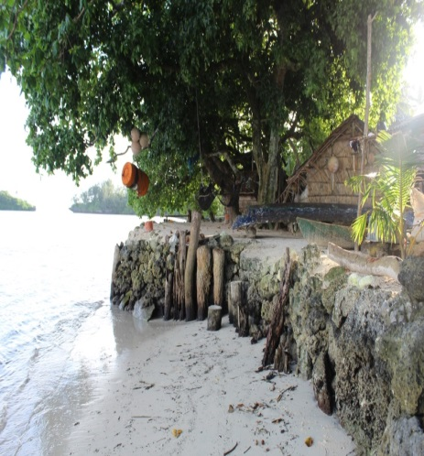 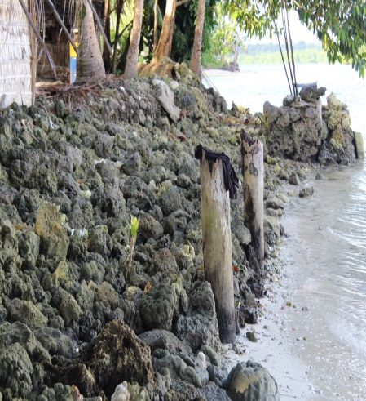 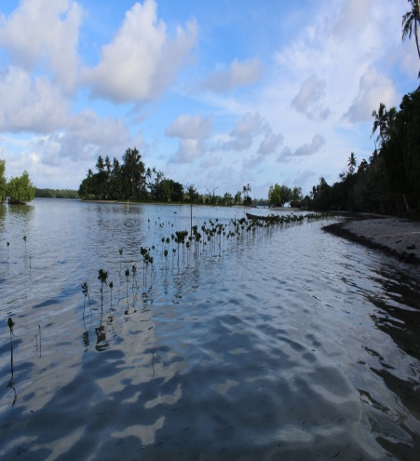Figure 14 Rock Boulders seawall Figure 15 Rock seawall Figure 16 Mangrove Planting
(Photo credit: John Whaleneanea)

The use of concrete seawall often requires major investments. They can be very costly to build, thus are only suitable and practical in urban areas and areas which have some level of development. In Solomon Islands examples includes, the Honiara Ports Area, Honiara Central Market and other major hotels that occupied the coastline which have concrete seawalls. Despite their costliness, they are proven to be more disaster proof.
Seawalls which use gabion nets are also effective and costly but unlike concrete seawalls, their lifespan depends on the wires ability to resist corrosion, its exposure to physical forces of nature such as large ocean swells and the chemical properties of the ocean or estuary.
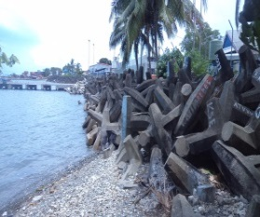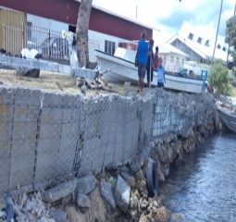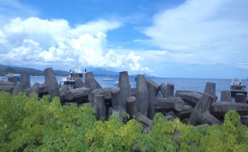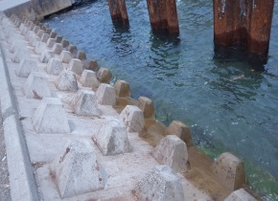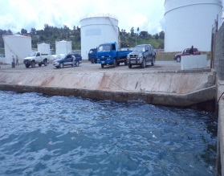
Figure 17 Breakwater structure. Figure 18 Gabion structure. Figure 19 Breakwater structure. Figure 20 Concrete revetment. Figure 21 Concrete seawall. (Photo credit: Moses )

Vanuatu
In Vanuatu, they have Seawall in Vila Harbour which was damage by cyclone. Vanuatu comprises of over 83 inhabited islands. Most people living on the coast have more or less ignored or done nothing in the name of engineering to counter the rising sea level and, or coastal erosion. Some – on coastal calm waters – have resort to building piling up rocks collected from the sand. This isn’t very much effective and is easily washed away during storms. Others who have extra funds to spend might be able to or have built concrete walls or use cement to hold the rocks together to form a seawall. This again isn’t very much effective during rough storms and overtime when the water digs around the walls. Yet others with funds and or with external sponsorship lay out gabion baskets and fill them up with rocks. In Luganville and Port Vila some portions of the coasts have been buried (land reclamation) and concrete and metal walls have been constructed. These engineering works have been done during the colonial era and mostly by the Americans during their brief stay in the country (during WWII). Because much money was put into this initiative and also because the water in these two locations is normally calm these structures have been in place for quite a while and can still be seen today. Sea level rise and frequent cyclones in the 90s have eroded the metal walls in Luganville and recent storms have damaged parts of the concrete/metal sea wall in Port Vila. Almost all the attempts discussed occur where the water is usually calm. Areas constantly exposed to rough seas largely ignore any engineering work at all as people know their efforts will be futile. (extract through the eyes of Vanuatu ICC-William Bani Arudovo).

Timor Leste
Wave breakers in front of port of Dili, mangroves, coastal and Marine Protected Areas on some of Timor Leste’s coast are common coastal engineering approaches found in Timor Leste. The mangrove planting sites are in Ulmera village, sub-district Bazartete and district Liquica. Timor Leste is working on ICM within the context of the Coral Triangle Initiative (CTI). They also have a community based national park called ‘Nino Konis Santana’.

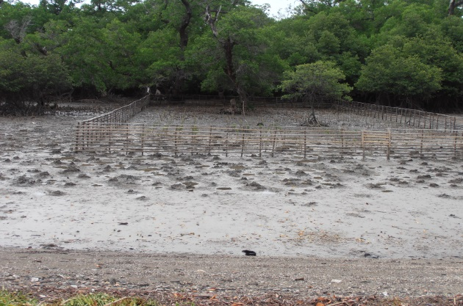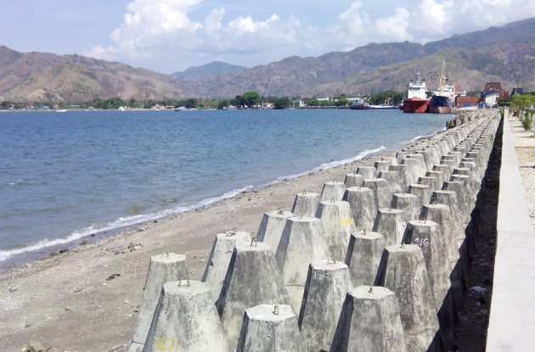
Figure 22 Mangroves in Ulmera village Figure 23 Wave breakers at port Dili, Timor Leste
(Photo credit: Ms Tessa

The current baseline information was updated based on SOPAC (1994):Coastal Protection in the Pacific Islands: Current Trends and Future Prospects.
Department of Environment, 2011. Integrated Coastal Management Framework for the Republic of Fiji.

