**Proposal to the Australian Climate and Oceans Support Program in the Pacific (COSPPac)**

**Tides and Oceans Management/Early Warning Support**

**Submitted by NOAA National Weather Service in the Republic of the Marshall Islands**

**May 2015**

**Request to COSPPac:**

Complement NOAA’s presence of Met Services in the region with $10,000 toward the capitalization of a Datawell Directional Waverider buoy to provide early warning support for the Republic of the Marshall Islands (RMI). The wave buoy provides data on wave height, wave direction, wave period, and sea surface temperature in near-real time (every 30 minutes).

**Total funds needed:**

A new wave buoy, shipped to Majuro and deployed, costs $80,000.  Purchase price of a Datawell Directional Waverider buoy is $75,000, including moorings, safety line. Shipping and deployment make up the remainder.

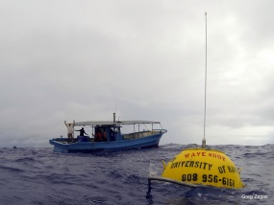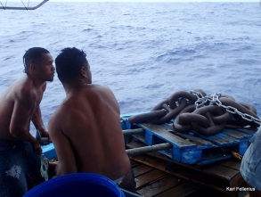

**Active Partners:**

The U.S. Integrated Ocean Observing System (IOOS) Program Office, based within NOAA National Ocean Service, has expressed a willingness to cost-share the purchase of a new wave buoy for Majuro. While the exact amount of this partnership is still to be determined, we are hoping that IOOS will be able to support at least 1/3 the cost of a new buoy. IOOS director, Zdenka Willis, recently visited Majuro and witnessed first-hand the value and need for a wave buoy in the RMI. She is determined to help identify and secure additional U.S. funding sources, including potential support from USAID and the U.S. State Department.

The Pacific Islands Ocean Observing System (PacIOOS) is committed to increasing the capacity for early warning in the RMI. Based on input from partners in the RMI (see below), PacIOOS has determined that a wave buoy in the RMI is essential to increase the safety and security of the people throughout the island nation. As a result, this effort is a priority for PacIOOS, who is currently collaborating with IOOS and other partners to identify additional sources of funding for another wave buoy for the RMI. PacIOOS will also utilize its reserve funds to help close the gap of the necessary amount to purchase a wave buoy. In addition, PacIOOS will commit the necessary resources for ongoing operations and management, including the annual cost of insurance for the buoy, which costs 10% of the purchase price per year.

Data from all PacIOOS wave buoys throughout the region are managed by the Coastal Data Information Program (CDIP) at Scripps Institution of Oceanography. Long-term partnerships between PacIOOS, the U.S. Army Corps of Engineers and CDIP enable data streaming into the PacIOOS website (<http://pacioos.org/wavebuoy/>) and PacIOOS Voyager (<http://pacioos.org/voyager>).

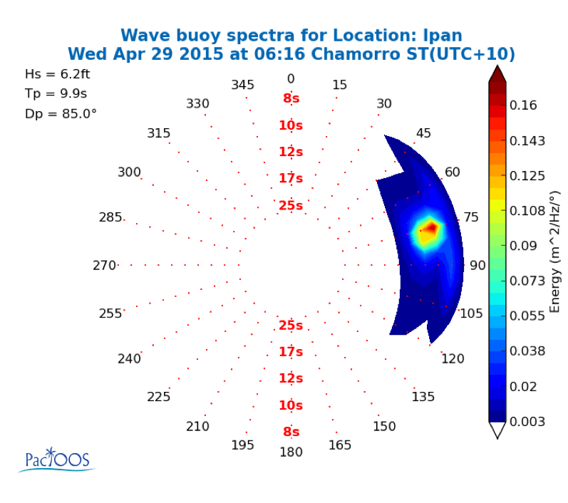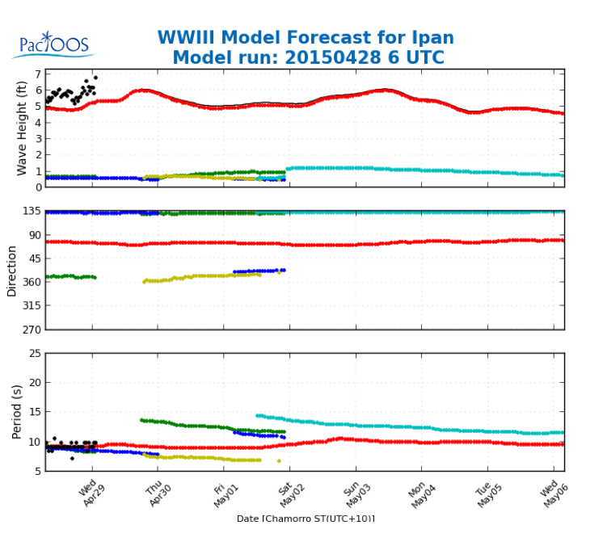

PacIOOS will resume the generation and dissemination of similar wave buoy spectra and forecasts incorporating WW3 forecasts with real-time wave buoy data (black dots on forecast on image on the right) for the RMI “Kalo” wave buoy once purchased and re-deployed.

Partners at the College of the Marshall Islands, the RMI National Disaster Committee (NDC), the University of Hawaii Sea Grant (based on Majuro) are currently identifying RMI funding support for this effort. Once the wave buoy is deployed, these partners are also essential to ensuring that stakeholders know the data and information are available and how to access them.

The NOAA National Weather Service is a partner as well as a major stakeholder for this effort. The major users of the data from the wave buoy include the NWS Weather Forecasting Office (WFO) in Guam (whose Area of Responsibility includes RMI) and the NWS Weather Service Office (WSO) in Majuro. The WSO uses the wave buoy data in real-time as part of their forecasting toolkit. The buoy data informs the decision of whether to issue notices to mariners, or warnings of extreme weather events to people residing in coastal areas. The buoy is the only source of off-shore information on local conditions that does not come from the Weather Forecast Office in Guam. The PacIOOS Inundation Index Forecast for Majuro (see images on next page) is also prominently displayed at the WSO in Majuro. While the forecast portion of this index is largely based on satellite imagery and global forecasts at the location of the wave buoy, the observed portion comes from the wave buoy and is used to validate the forecast.

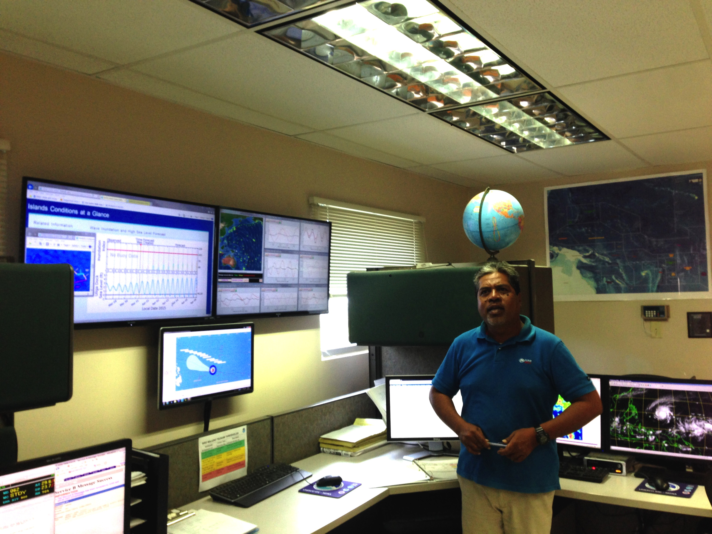"PacIOOS has been a tremendous ally for us ocean wave forecasters west of the International Date Line,” said Warning Coordination Meteorologist at WFO Guam, Chip Guard. “The Majuro wave buoy has revealed many of the unique characteristics of the potentially destructive waves that threaten the atoll from the east, south and west. It will reveal more secrets, and we will eventually solve the wave forecasting challenge at Majuro." *– Marshall Islands Journal July 25, 2014.*

# Forecast of the Potential for High Sea Level and Wave Inundation Along the Ocean-facing Shorelines of Majuro Atoll, RMI

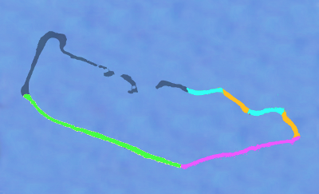

**Synopsis:** Four separate color-coded forecasts of potential inundation are provided for the ocean-facing shorelines of the most populous islands of Majuro Atoll.  A sea level forecast without swell effects is also provided for Uliga Dock inside the atoll at its eastern end.

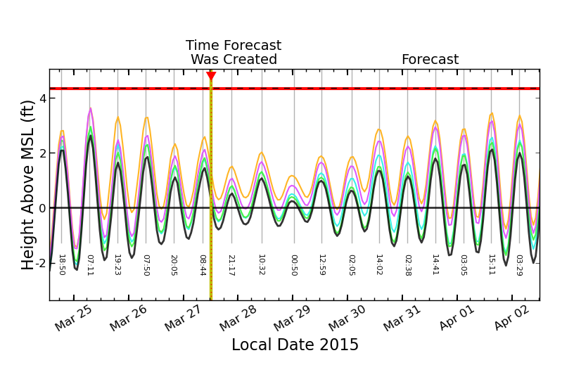

**Contacts:**

Reginald White, NOAA NWS WSO Majuro, [Reginald.White@noaa.gov](mailto:Reginald.White@noaa.gov)

Melissa Iwamoto, PacIOOS Deputy Director, [Melissa.Iwamoto@hawaii.edu](mailto:Melissa.Iwamoto@hawaii.edu)

Karl Fellenius, PacIOOS Liaison for RMI, [karl.fellenius@hawaii.edu](mailto:karl.fellenius@hawaii.edu)

**Additional Stakeholder Value of the Wave Buoy to the RMI:**

PacIOOS has a number of partners in the Marshall Islands, including a many others interested in seeing the wave buoy re-installed.

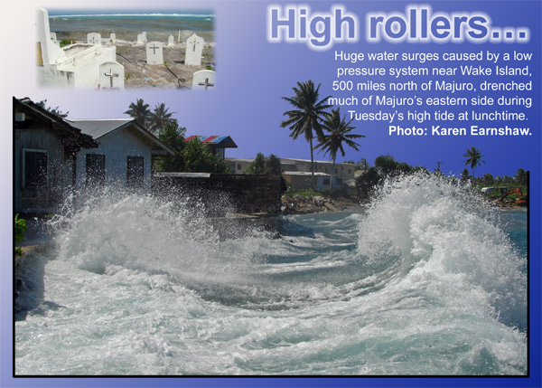National Disaster Committee (NDC) and Emergency Operations Center (EOC)

The NDC acts upon the information provided by the WSO by activating the EOC and alerting the public via local media. In the cases of wave inundation and typhoons the NDC also directs the Ministry of Public Works to build berms in vulnerable areas. All resources within the national disaster management structure are utilized and response plans are put into action. The reliability of the PacIOOS 6-day forecast for inundations (and therefore the effectiveness of the wave buoy validation) becomes part of the decision-making process for identifying when conditions will allow for various mitigation actions/assessments/recovery to take place.

Chief Secretary’s Office (CSO) and Office of Environmental Policy and Planning Coordination (OEPPC)

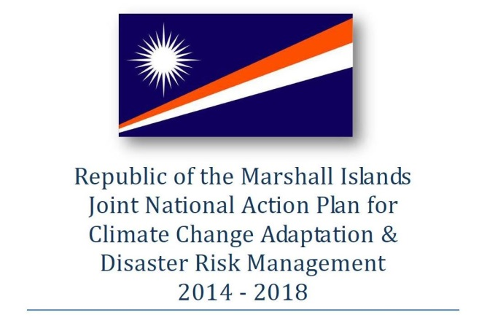The NDC is chaired by the CSO. Both the EOC National Emergency and Disaster Management Officer (NEDMO) and the Coordinator for the JNAP (Joint National Action Plan) for CCA and DRM (climate change adaptation and disaster risk management) are located at the CSO. The CSO and OEPPC jointly manage the JNAP Secretariat. The NEDMO and JNAP Coordinator both support the efforts of PacIOOS and understand the linkages between the early warning system in the JNAP, the inundation index, and the wave buoy. It is the CSO and OEPPC, via the decisions taken at the NDC and implemented through the JNAP Secretariat and the WSO, that drive the RMI national support for the wave buoy. This support for PacIOOS may not be financial at this time, but few other non-national programs in the RMI experience similar levels of policy integration and recognition by these senior government entities.

Jenrok Community Early Warning National Coordinating Team (FINPAC Project)

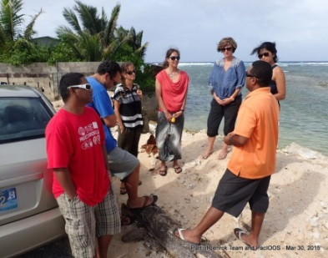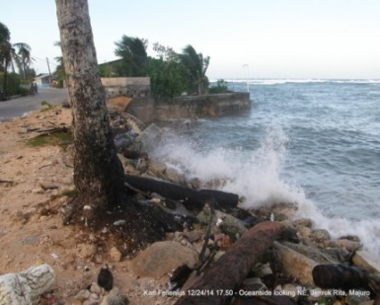This Pilot Project focuses on developing and testing a community-based early warning system, linked to the provision of relevant and timely information about imminent weather and climate hazards from the WSO. The Marshall Islands Red Cross (MIRC) and the International Federation of the Red Cross (IFRC) in Micronesia are leading collaborators in the effort along with the WSO. Other members include CSO, EOC, JNAP, Marshall Islands Police Dept., University of the South Pacific, and University of Hawaii Sea Grant (UH Sea Grant) at the College of the Marshall Islands (CMI).

All members receive the PacIOOS inundation index notices when they are sent out to RMI stakeholders and the public by the UH Sea Grant/PacIOOS liaison in advance of possible wave inundation events. It is in part through this notification effort that the National Coordinating Team has identified the inundation index and the re-installation of the wave buoy as necessary features of an integrated early warning system for the community of Jenrok.

Majuro Atoll Local Government (MALGOV) and Djarrot Reimaanlok Committee

Several meetings have taken place in recent years with government and non-government agencies, potential donors, contracted engineering firms, and among the surrounding community of Jenrok which have identified Jenrok Village as the new municipal solid waste landfill site. In response, MALGOV and the Djarrot Reimaanlok Committee has been consulting with various experts on what scientific data gathering activities that would be needed to better inform a comprehensive Environmental Impact Assessment. They have learned that the wave buoy data is among those critical datasets which make possible a comprehensive Environmental Impact Assessment (EIA) for the site comprising the entire Jenrok and surrounding (i.e. Rita and Uliga) areas.

College of the Marshall Islands (CMI) and Marshall Islands Conservation Society (MICS)

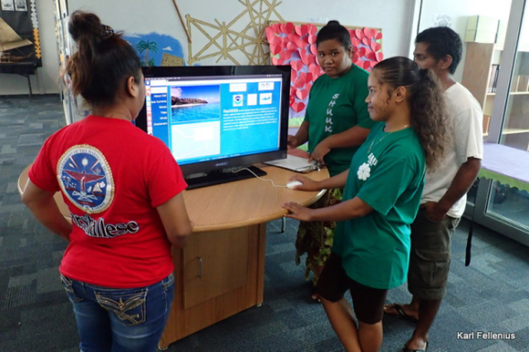CMI via a partnership with UH Sea Grant houses the PacIOOS Liaison, and is a founding partner of the PacIOOS program in the RMI. Students at the CMI Library engage in learning at a Kiosk that displays wave buoy information along with other aspects of the program. The College is currently coordinating a focused inundation modeling effort for the densely-populated portion of Majuro atoll for inclusion in the *RMI Homeowners Handbook to Prepare for Natural Hazards*. Integral to the chapters on hazard risk and emergency protocols is a discussion on early warning via the inundation index and wave buoy. CMI also houses MICS which benefits from the wave buoy data specifically in terms of having available quantitative tools for climate vulnerability assessments as part of the ecosystem-based adaptation framework called *Reimaanlok* (looking to the future), which is the National Conservation and Community-Based Resource Management Planning Framework championed by the Coastal Management Advisory Council (CMAC) and under the purview of the National Climate Change Committee (NC3) chaired by the CSO. While focused on Majuro, the data from the wave buoy is broadly applicable to the whole of the RMI.

RMI Environmental Protection Authority (RMI EPA) and Ministry of Public Works (PWD)

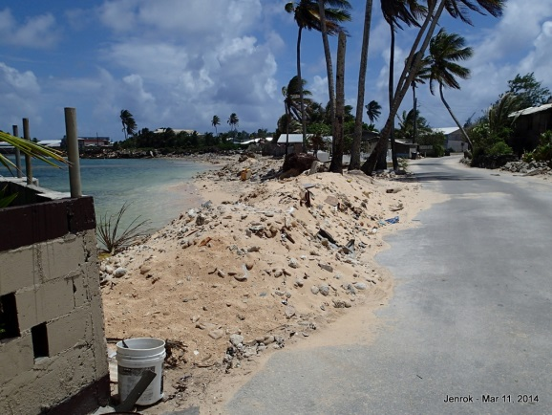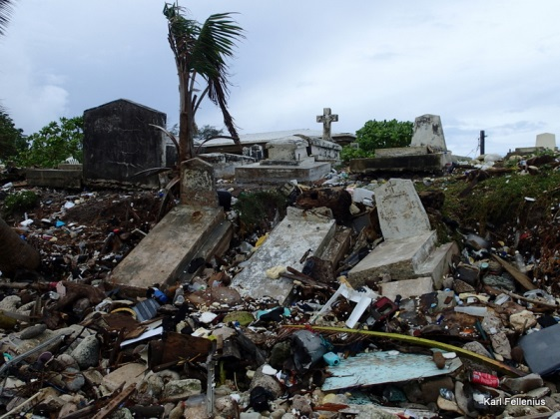The Coastal, Land and Conservation Division of the RMI EPA needs information on wave energy settings to better assess landowner applications for proposed development along shorelines. The wave buoy provides much sought-after data to support inundation modeling in vulnerable areas. Wave energy data from the wave buoy will also be used in a proposed collaborative effort led by the RMI EPA to produce coastal protection guidelines from reef to ridge that encompass a range of soft and hard options informed by both coral reef managers and coastal engineers. Such guidelines will enable the PWD to make better and more environmentally-friendly berms in preparation for wave inundation events, beyond the current practice of using sand only.

Marshall Islands Marine Resources Authority (MIMRA)

The primary benefit of the wave buoy to MIMRA outside of its obvious fishing vessel safety aspects is ocean side Sea-Surface Temperature (SST) monitoring. Combined with lagoon side monitoring via the PacIOOs water quality sensor, this time series of data provides an on-the-ground validation of SST satellite products from NOAA Coral Watch to give early warning of coral bleaching events. Significant information from both the wave buoy and water quality sensor comparing Aug-Dec in 2010 and 2014 was used in a recent national coral bleaching report for the RMI.

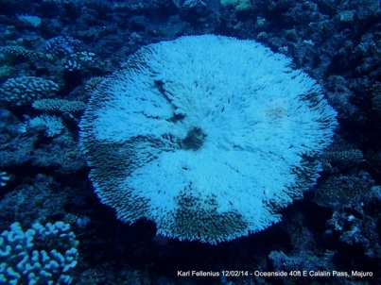



MIMRA is involved with the vessel monitoring scheme, and will provide PacIOOS with the history of vessel movements in the area of the wave buoy location. They can also communicate the position of the wave buoy to fishing vessels via the responsible shipping agents. This will increase the confidence that the re-deployed wave buoy will not be affected by vessel traffic.

RMI Port Authority (RMIPA)

Similar to MIMRA, the RMIPA can communicate the position of the wave buoy to vessels operating within its jurisdiction, and benefit from the increased level of awareness of sea conditions for vessel safety.

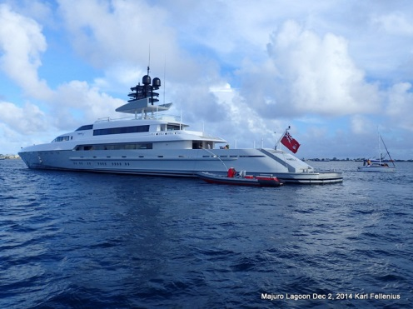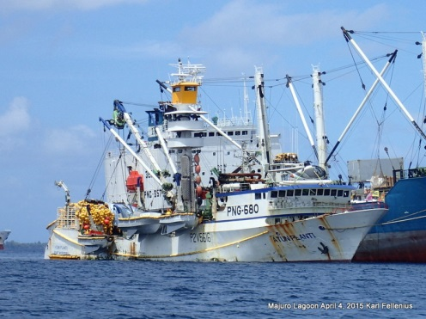

Billfish Club, Mieco Beach Yacht Club, and WAM (Waan Aelõñ in Majel - Canoes of the Marshalls)

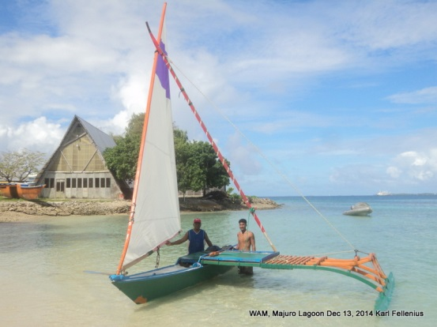These not-for-profit organizations are centered in Majuro but are active throughout the RMI. They are likely the most-informed local users of weather information, notably wind and swell conditions and small craft warnings coming out of the WSO. Mieco Beach is a PacIOOS partner and the Billfish Club is pending. Key members receive the PacIOOS inundation index notices when they are sent out to RMI stakeholders and the public by the UH Sea Grant/PacIOOS liaison in advance of possible wave inundation events, and Mieco Beach has explicitly requested additional packaging of data on local currents via PacIOOS.

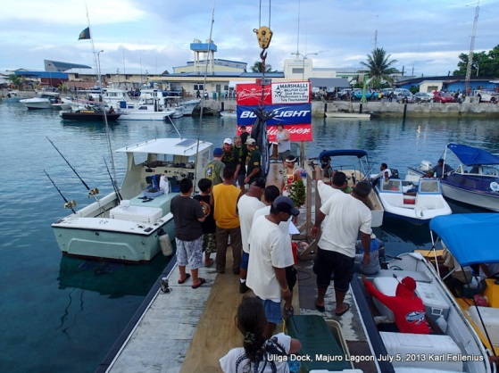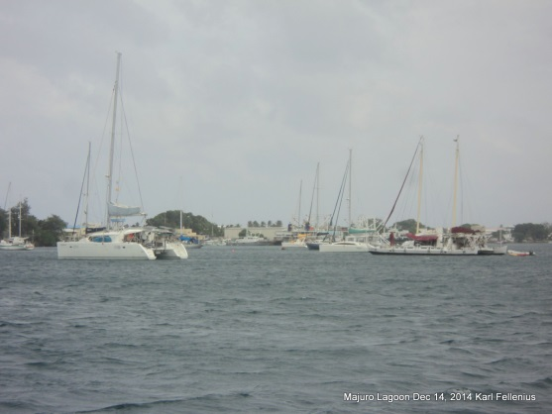

US Embassy, USAID and International Organization for Migration (IOM) in Majuro

The US Embassy in Majuro has repeatedly expressed their support for the PacIOOS program in the RMI since its inception. Most recently they spoke at a reception for PacIOOS and IOOS in Majuro for RMI stakeholders. On April 8, 2015, the US Embassy posted on their Facebook page:

“The Pacific Islands Ocean Observing System (PacIOOS) Executive Committee visited Majuro last week, along with special guests from the Integrated Ocean Observing System (IOOS). PacIOOS works with many local stakeholders to advance mutual objectives. Here in the RMI, it continues to play an important role in the deployment of the Majuro wave buoy and water quality sensor. PacIOOS along with their local liaison Karl Fellenius (Univ of Hawai’i Sea Grant) are also important contributors in the national effort to deal with wave inundation, via forecasts for inundation events on Majuro and Kwajalein Atolls.”

USAID through IOM has the responsibility for response during, and reconstruction after significant disasters in Compact of Free Association countries. IOM relies on effective coordination with the WSO, NDC, CSO, & EOC described above. The early warning and forecast validation via the wave buoy provides them with additional confidence in the timing and coordination of preparations for the pre-positioning of emergency supplies and the implementation of standard operating procedures and other emergency protocols.

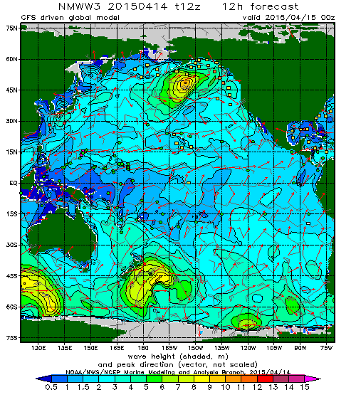NOAA Pacific Region Climate Information Services and Pacific ENSO Applications Climate Center (<http://www.pacificcis.org/dashboard_freshwater/>)

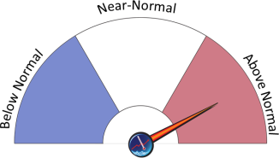Over the last couple of years there has been an effort to further generate, transform, and transmit relevant climate information to the Pacific Region by NOAA, COSPPac, and partners. In the RMI there was an April 2014 workshop on Freshwater Security and Drought, and a conversation series in April 2015 on Water, Disaster Management, and Agroforestry. All of these sector approaches have a common theme – the need for longer-term early warning of weather and climate indicators related to wave inundation from a variety of coastal hazards. The work strives to link specific sector responses to the provision of timely climate forecast variables in the form of an easy-to-understand dashboard. Several of the models use data from the wave buoy, and as such, the program would benefit significantly from its re-deployment.